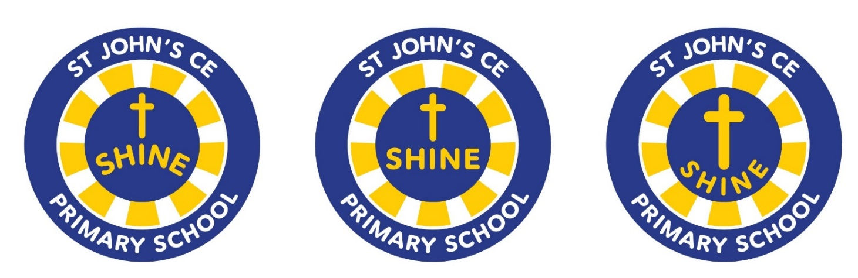**St John’s School Performance Data 2023-24**

**Reception**

Children are defined as having reached a Good Level of Development (GLD) at the end of Reception if they have achieved at least the expected level for the Early Learning Goals (ELGs) in the prime areas of learning and the specific areas of maths and literacy.

|  |  |  |
| --- | --- | --- |
| Assessment: Good Level of Development | All Pupils | National Early Years Data 2022 |
| GLD | 69.4% | 67% |

**Year 1**

The Phonic Screening Check is a check of your child’s phonic knowledge. It helps to confirm whether your child has made the expected progress. The phonics check is a mix of ‘real words’ and ‘non-words’. Children cannot read the non- words by using their memory or vocabukary; they must use their decoding/phonic skills.

|  |  |  |
| --- | --- | --- |
| Assessment: Phonics Screening Check | All Pupils | National Year 1 Data 2022 |
| Year 1 Phonics Screening | 97.4% | 81.25% |

**Year 2: End of Key Stage 1**

|  |  |
| --- | --- |
| Assessment: End of Key Stage 1 | All Pupils |
| Maths Expected + | 74.1% |
| Reading Expected + | 70.4% |
| Writing Expected + | 62.9% |
| Reading, Writing, Maths Combined Expected + | 60% |

**Year 6: End of Key Stage 2**

|  |  |  |
| --- | --- | --- |
| Assessment: End of Key Stage 2 | All Pupils | National Year 6 Data 2022 |
| Maths Expected + | 78% | 73% |
| Maths Average Scaled Score | 103 | 104 |
| Reading Expected + | 78% | 74% |
| Reading Average Scaled Score | 104 | 105 |
| Writing Expected + | 78% | 72% |
| Writing Greater Depth | 19% | 20% |
| Grammar, Spelling and Punctuation Expected + | 73% | 72% |
| Grammar, Spelling and Punctuation Average Scaled Score | 103 | 104 |
| Reading, Writing, Maths Combined Expected + | 73% | 59% |
| Reading, Writing, Maths Combined Greater Depth | 0% | 7% |