00---

**Choice A**

Traditional Roast Chicken Dinner

**Choice B**

Fresh Vegetable Risotto.

**Choice C**  
Fresh Cheddar Cheese & Salad Wrap

**Vegetable Selection**   
Creamed & Roast Potatoes  
Seasonal Fresh Vegetables

**Dessert**

Fresh Fruit & Jelly Pots

Cheese and Crackers

Basket of Fresh Seasonal Fruit

Organic Yeo Valley Yoghurt

Over 75% of the food on this menu is homemade by our dedicated Catering Teams and cooked on site. We use high quality regionally sourced products, including some organic. We use higher animal welfare meat and MSC Fish. fresh salad bowl, wholemeal bread and fresh drinking water is served daily.

A fresh salad bar, wholemeal bread and drinking water are available daily.

Thursday

Wednesday

Tuesday Meat free

**Choice A**

Farm Assured oven Baked Sausages

**Choice B**

Homemade Macaroni Cheese

**Choice C**

Jacket Potato with Tuna & Sweetcorn Filling

**Vegetable Selection**

Creamed Potatoes

Sweetcorn

Garden Peas

**Dessert**

Homemade Bakewell Tart served with Creamy Custard

Basket of Fresh Seasonal Fruit

Organic Yeo Valley Yoghurt

**Choice A**

Homemade Spaghetti Bolognese

**Choice B**

MSC Fish Fingers

MSC Salmon Fish Fingers

**Choice C**

Egg Mayonnaise Sandwich

**Vegetable Selection**

Homemade Herby Diced Potatoes

Medley Of Vegetables

Baked Beans

**Dessert**

Fruity Mousse made with Organic Milk

Basket of Fresh Seasonal Fruit

Organic Yeo Valley Yoghurt

Friday Meat free

**Choice A**

Homemade Pizza Margherita

**Choice B**

Vegetarian Ravioli

**Choice C**

Jacket Potato with Baked Beans filling

**Vegetable Selection**

Oven baked Chunky Chips

Baked Beans

Salad Pots

**Dessert**

Homemade Shortbread Round

Basket of Seasonal Fruit

Organic Yeo Valley Yoghurt

**Choice A**

Wholemeal Pasta Arabbiatta served with Garlic Bread

**Choice B**

Homemade Cheese & Onion Pie

**Choice C**

Jacket Potato with Baked Beans Filling

**Vegetable Selection**

Seasoned Homemade Potato Wedges

Peas & Sweetcorn

**Dessert**

Homemade Chocolate & Pear Sponge with Creamy Custard

Basket of Fresh Seasonal Fruit

Organic Yeo Valley Yoghurt

Our award-winning Oldham Education Catering Service guarantees that children are getting a healthy balanced meal 5 days a week using fresh products cooked onsite each day.

**www.oldham.gov.uk/school meals Allergen information available on request**

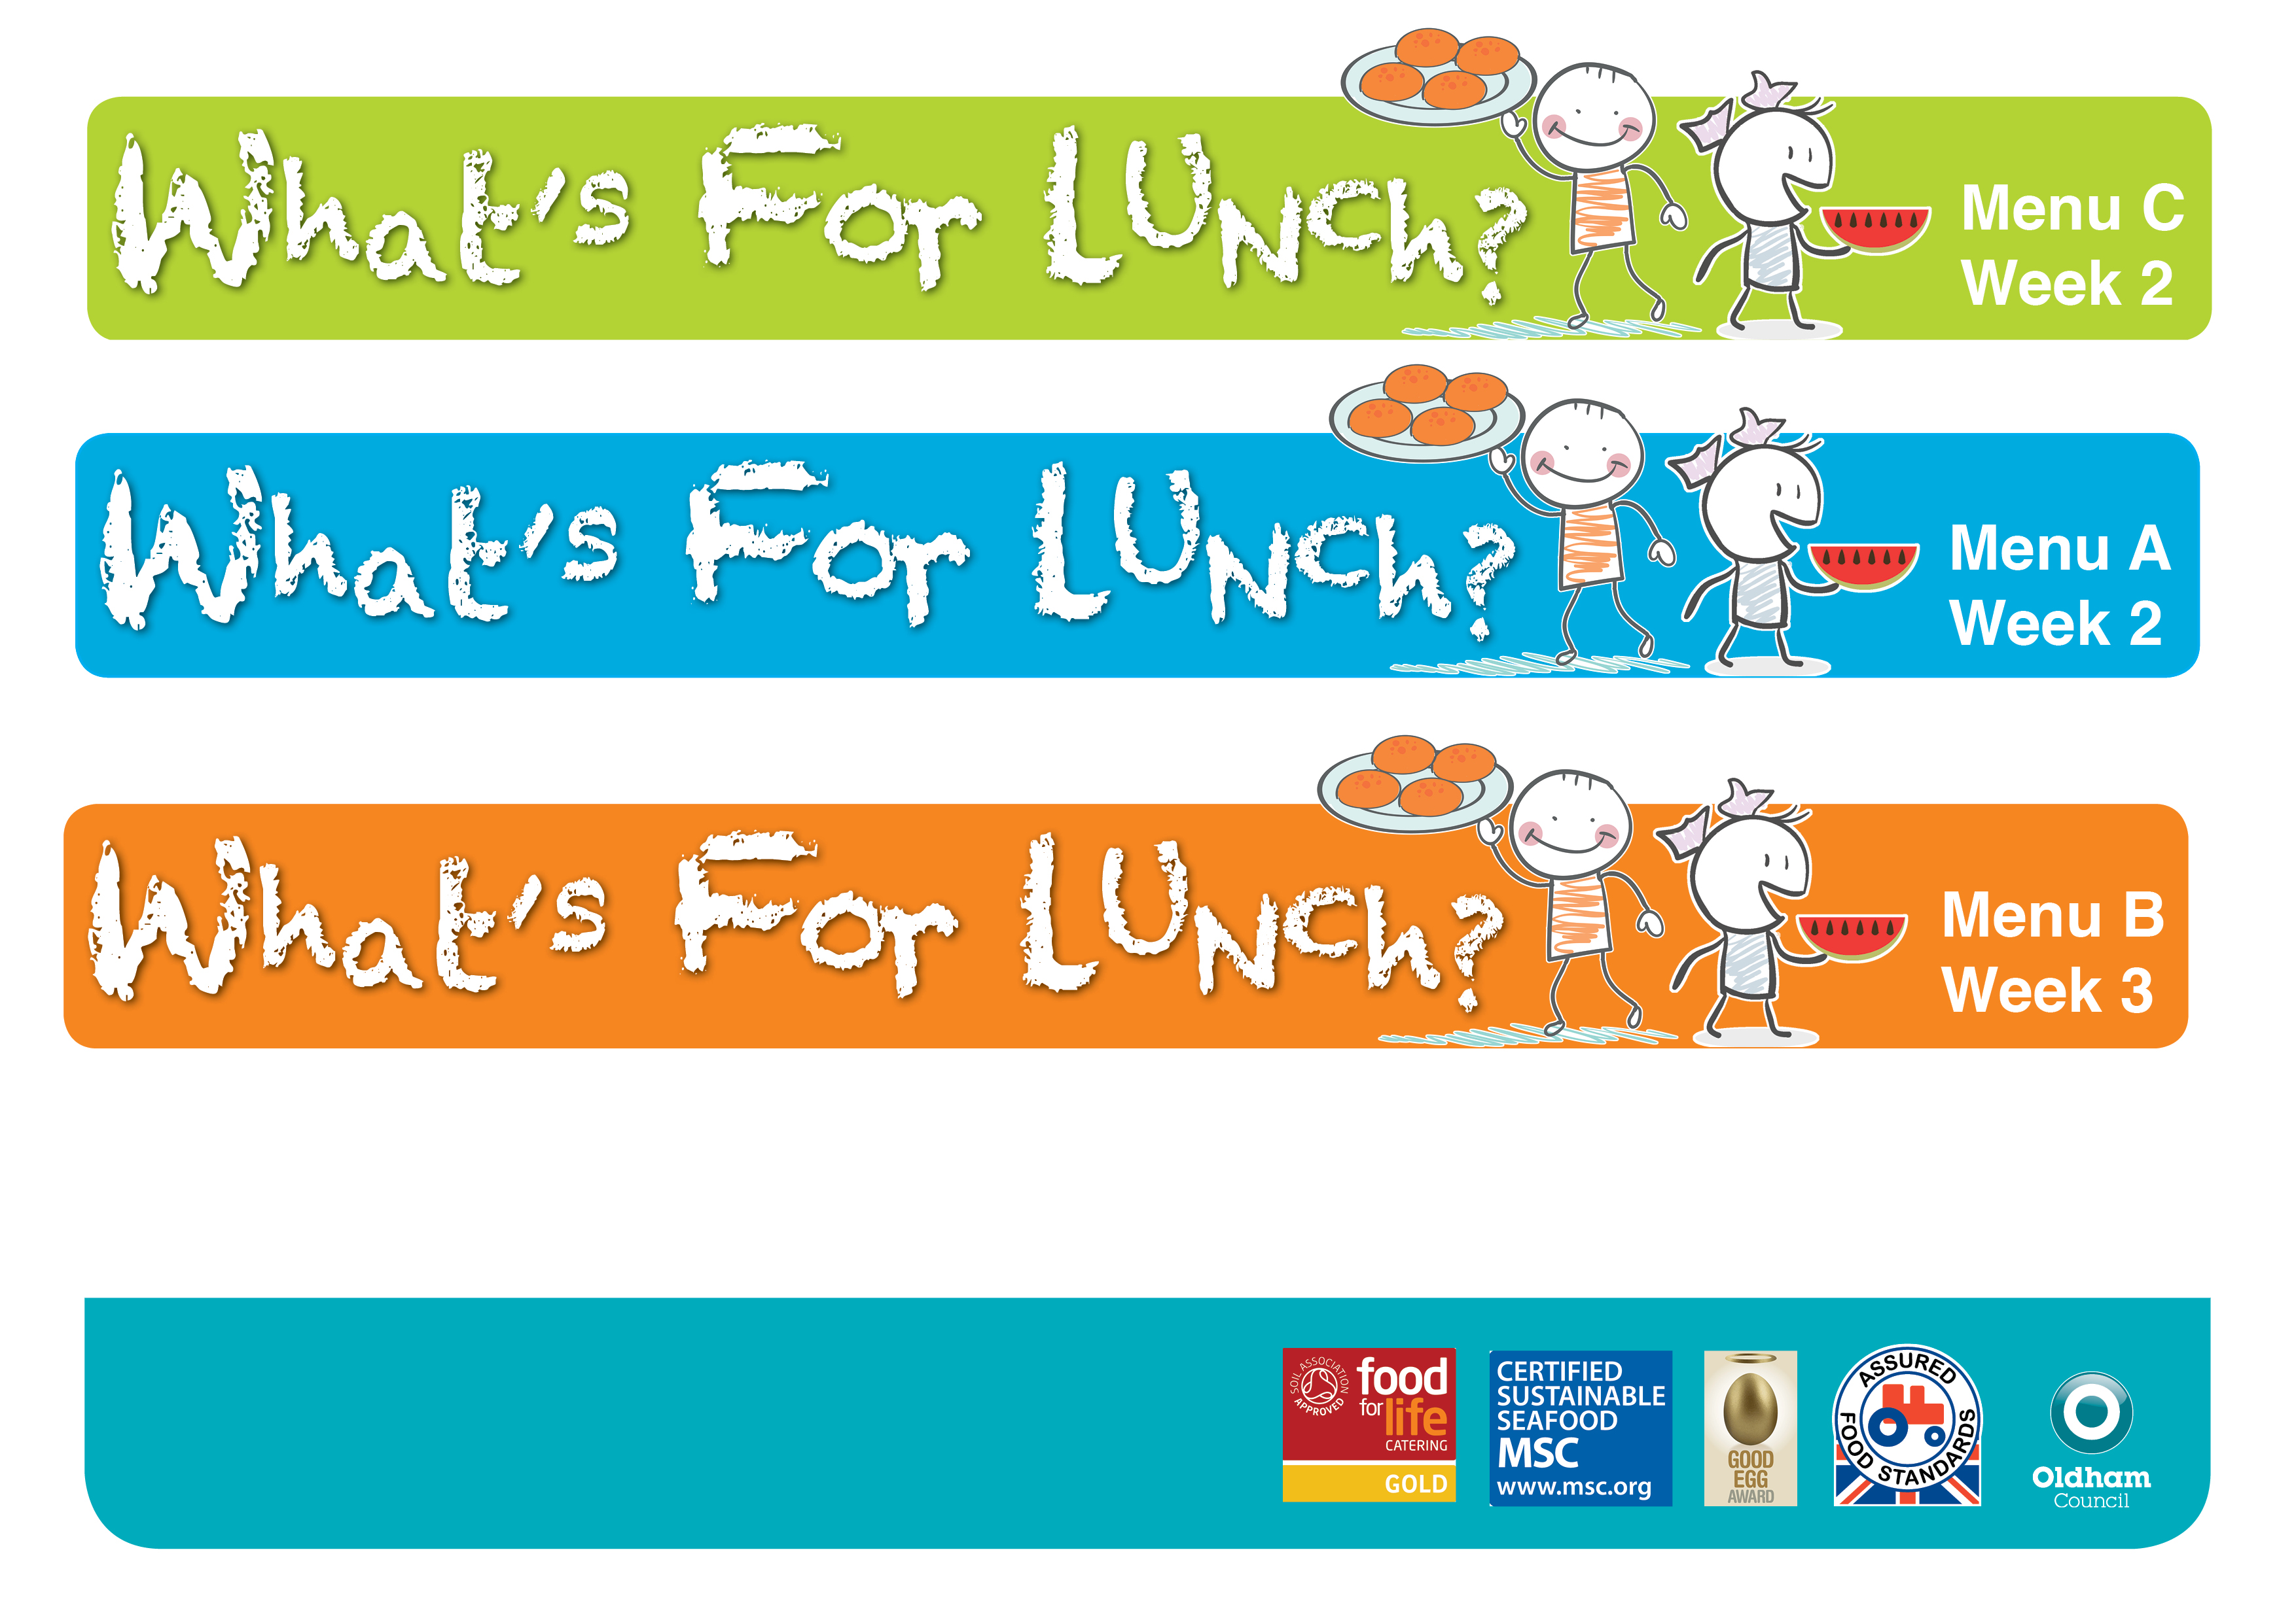  **Spring Summer 2023**  

Monday

**H**

