St. John’s Church of
England Primary School
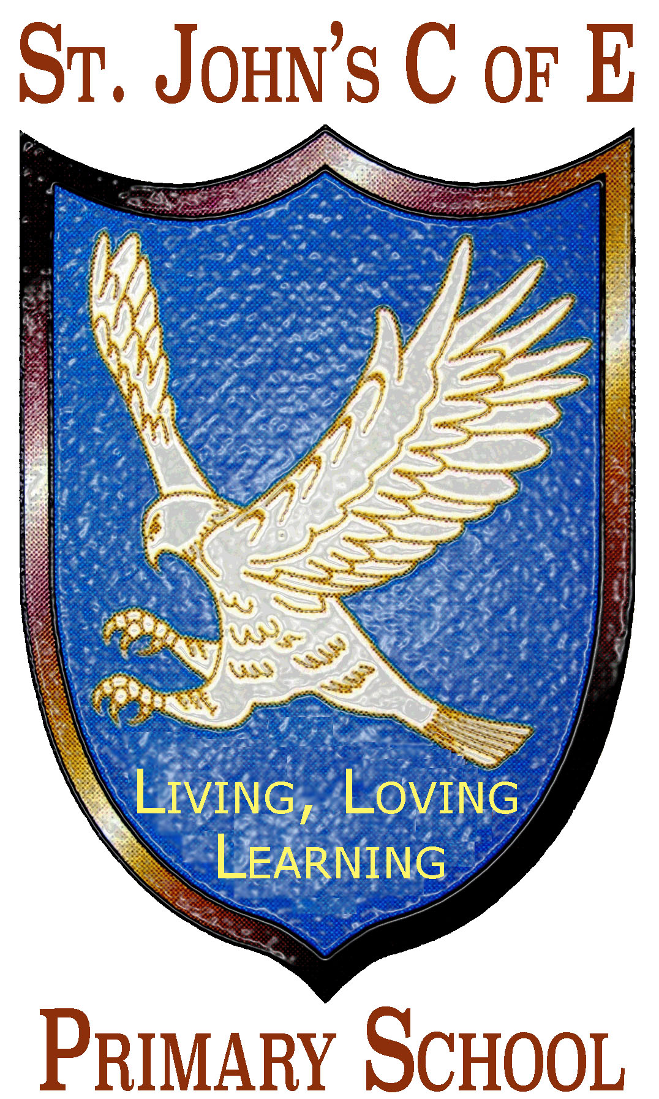
Policy for RE

Reviewed on September 2020
Next Review Date September 2022
“Let all that you de be done in Love” 1 Corinthians 14:16

Document purpose
This document reflects the school values and philosophy in relation to the teaching and learning of Religious Education. It sets out a framework within which both teaching and non-teaching staff can operate, and it gives guidance on planning, teaching and assessment.
Audience
This document is intended for:
- All teaching staff and staff with classroom responsibilities
- The school governors
- Parents
- LEA advisors/inspectors
- Inspection teams
Subject Aims
Religious Education is included as a foundation subject within the National Curriculum. The aims of RE are consistent with our school philosophy and take account of LEA Curriculum Policy and National Curriculum Non-Statutory Guidance.
Religious Education should:
Support children in reflecting upon, developing and affirming their own beliefs, values and attitudes, through an exploration of shared human experiences and of the place and significance of religion in the contemporary world.
At St. John’s C of E Junior School, Religious Education plays an important role in promoting the spiritual, moral, social and cultural development of our children.
The approach to Religious Education
At St. John’s C of E Junior School, the teaching of RE is approached with the following principles in mind:
There are no presumptions made as to the religious backgrounds, beliefs and attitudes of the children and staff. We value the religious backgrounds of all members of the school community and hope that this will encourage individuals to share their own experiences with others freely. All religions and their communities are treated with respect and sensitivity and we value the links between home, school and a faith community. We acknowledge that each religion studied can contribute to the education of our pupils. We promote teaching in RE that stresses open enquiry and first-hand experiences wherever possible for both staff and children. The syllabus is implemented in school by means of a sensory approach, where children may look at and handle religious artefacts or hear music from religious traditions.
The implementation Religious Education
Work in RE follows a structure based on the National Curriculum programmes of study and QCA guidelines, and is supplemented by topics from the Diocese of Manchester / Blackburn Schemes of Work and In the Beginning St Edwards R.C. Scheme of Work.
As we are a C of E aided school, Christianity is the predominant religion studied. Children also study religions such as Hinduism, Islam and Judaism as they progress through the school.
The framework used at St John’s Primary School outline the provision for RE throughout the whole school and indicates the progression and continuity which has been built into the teaching of RE. The frameworks have four broad aims:
- Exploring shared human experiences
- Developing pupils’ own beliefs, values and attitudes
- Learning about the place and significance of Christianity and other religions in the contemporary world
- Experiencing world religions as living faiths
Time allocation
The teaching of RE is in line with government recommendations. RE is taught for one hour per week, throughout the year.
Curriculum and School Organisation
The Schemes of Work used for RE (QCA, Diocese of Blackburn / Manchester Scheme of Work and In the Beginning St Edwards R.C. Scheme of Work) outline in detail how it should be taught in each year group. The subject co-ordinator oversees the planning in RE.
RE can be taught in a number of ways:
- Direct teaching to the class or small groups
- Providing direct hands-on experience with RE resources, such as photographs, ICT or artefacts
- By using teacher-prepared materials such as worksheets through stories, poetry and drama
- Through visits to and from faith communities
A range of reference materials for RE is available. These are audited and supplemented annually by the RE coordinator and kept centrally for all staff to use as required.
Pictorial materials such as picture packs are used as a valuable resource. ICT resources are also used. These include CD ROMs, DVDs and a wide range of RE websites. A list of these websites has been compiled by the coordinator and is available to all staff.
Every effort is made to link with local faith communities and it is hoped that they will wish to contribute to school, by visiting to discuss their faith with the children.
Links with other subjects
RE has links with other areas of the Curriculum, including Literacy, PSHCE, ICT, Music, History and Art. It also linked to the way in which the school organises its Collective Worship. Worship is provided daily, and while it is seen as being distinct from RE, there are certain links which can be identified. For example: during the various forms of collective worship, there will be time given for the members of the local community to reflect; there will be opportunities for spiritual development; a particular RE theme may be developed; and class teachers may use their year group theme as part of their class assembly.
Assessment, Record Keeping and Reporting
See policy for Assessment, record keeping and reporting.
Equal opportunities
All teaching and non-teaching staff are responsible for ensuring that all pupils, irrespective of gender, ability, ethnicity and social circumstances, have access to the whole curriculum and opportunities to make the greatest progress possible in all areas of the curriculum whilst in our school.
Evaluation
Evaluation is carried out to inform the teaching and learning of RE within our school. It is the responsibility of the coordinator to monitor and evaluate the curriculum provision mode for RE within the school, in order that the pupils make the greatest possible progress.
This includes an annual evaluation of the content of the RE curriculum to ensure that all the requirements are being fulfilled in the best possible way. Monitoring of planning is carried out to check that plans are actively put into action in the classroom. Pupil’s progress and performance is evaluated. Evaluation may take place by means of a number of methods, including:
- Looking at children’s work
- External inspection and advice
- Lesson observations
Evaluation will be an ongoing process but will be formalised on an annual basis.
Data Protection Statement

The procedures and practice created by this policy have been reviewed in the light of our Data Protection Policy. All data will be handled in accordance with Sole Fide Church of England Multi Academy Trust’s Data Protection Policy.

Data Audit for the Policy

As such our assessment is that this policy:

Has Few/No Data Compliance Requirements |  |  | Has Moderate Level of Data Compliance Requirements |  |  | Has High Level of Data Compliance Requirements
 | x

