Here to Help
CITIZENS ADVICE  www.citizensadvice.org.uk  Adviceline: 0800 144 8848  Online and telephone free advice to help find a way forward whatever the problem | 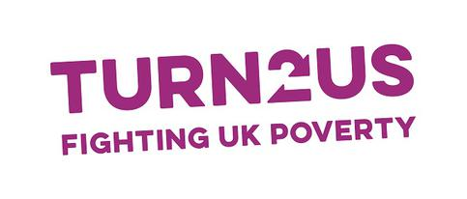  Turn2Us  www.turn2us.org.uk  Helpline: 0808 802 2000 9-5 Mon-Fri Calls free from all landlines and most mobiles  Email: info@turn2us.org.uk  National charity providing information and financial support to help people get back on track
GOV.UK  www.gov.uk  The place to find government services and information | 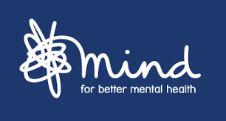  MIND  www.mind.org.uk  Info line: 0300 123 3393 9-6 Mon-Fri (except bank holidays)  Mental health charity, ensuring no one has to face a mental health problem alone
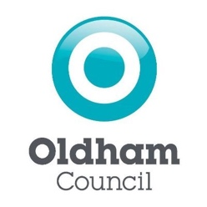  OLDHAM COUNCIL  www.oldham.gov.uk  Individual department contact details on website. | 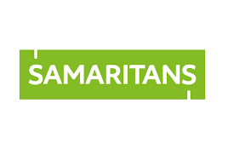  SAMARITANS  www.samaritans.org  24 hour helpline 365 days a year: 116 123  Email: jo@samaritans.org  A non-judgmental listening service for any problem
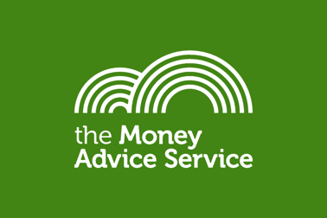  MONEY ADVICE SERVICE  www.moneyadviceservice.org.uk  Adviceline : 0800 138 7777  Free financial help and information | BRITISH ASSOCIATION FOR COUNSELLING AND PSYCHOTHERAPY  www.bacp.co.uk  Find a counsellor/therapist
OLDHAM HEALTHY MINDS  www.penninecare.nhs.uk > healthyminds  Offers support and treatment to people over 16 years who are registered with an Oldham GP and are experiencing difficulty with mental health  THE ANCORA PROJECT  www.oldham.gov.uk  0161 669 5868  Email: ancora@keyring.org  Aims to provide immediate help and on-going support to people who are experiencing crisis | 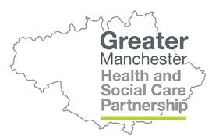  GREATER MANCHESTER HEALTH AND SOCIAL CARE PARTNERSHIP  Offers freely accessible resources available to anybody who is looking for help with their mental health.  https://hub.gmhsc.org.uk/mental-health/covid-19-resources/  There is a guide available which provides advice and tips on how to look after yourself and others during the pandemic  https://ub.gmhsc.org.uk/mental-health/wp-content/uploads/sites/6/2020/05/Wellbeing-and-mental-health-during-COVID-19.-A-guide-to-looking-after-yourself-and-others.pdf  For mental health support where you live in Greater Manchester, including helplines, counselling and online support – you can use this map to find what services are available close to home.  https://hub.gmhsc.org.uk/mental-health/in-your-area/

