Thursday

**Choice A**

Homemade Creamy Pasta Carbonara

**Choice B**

Homemade Cheese and Tomato Quiche

**Choice C**

Savoury Tuna filled Roll

**Vegetable Selection**

Roast Potatoes

Fresh Broccoli

Medley of Vegetables

**Dessert**

Homemade Oaty Chocolate Cookie

Fresh Seasonal Fruit

Organic Yeo Valley Yoghurt

**Choice A**

Homemade Deep Meat and Potato Pie

**Choice B**

MSC Fish Cake

**Choice C**

Jacket Potato with Savoury Cheese Coleslaw

**Vegetable Selection**

Creamed Potatoes   
Seasonal Fresh Vegetables

**Dessert**

Arctic Roll & Fresh Fruit Salad

Cheese and Crackers

Basket of Fresh Seasonal Fruit

Organic Yeo Valley Yoghurt

Wednesday

Tuesday

**Choice A**

Tasty Beefburger in a Bun served with Homemade tomato sauce

**Choice B**

Homemade Wholemeal Pasta Roma

**Choice C**

Tuna Filled Wrap

**Vegetable Selection**

Homemade Oven Baked Wedges

Peas &Sweetcorn

**Dessert**

Homemade Marble Sponge made with Fruit Coulis served with Custard

Basket of Fresh Seasonal Fruit

Organic Yeo Valley Yoghurt

**Choice A**

Chefs Choice Homemade Pizza

**Choice B**

Savoury Omelette

**Choice C**

Jacket Potato & Baked Beans

**Vegetable Selection**   
Oven Baked Chunky Chips Baked Beans

Salad Pots

**Dessert**

Homemade Ginger Sponge & Creamy Custard

Basket of Fresh Seasonal

Fruit

Organic Yeo Valley Yoghurt

Friday Meat free

Monday

**Choice A**

Homemade Chicken Pilaf Served with 50/50 Rice

**Choice B**

Quorn Veggie Sausage

**Choice C**

Jacket Potato with Savoury Cheese filling

**Vegetable Selection**

Homemade Herby Diced Potatoes

Baked Beans

**Dessert**

Homemade Fruity Flapjack Finger  
Seasonal Fresh Fruit

Organic Yeo Valley Yoghurt

Our award-winning Oldham Education Catering Service guarantees that children are getting a healthy balanced meal 5 days a week using fresh products cooked on site each day.

**www.oldham.gov.uk/school meals Allergen information available on request**

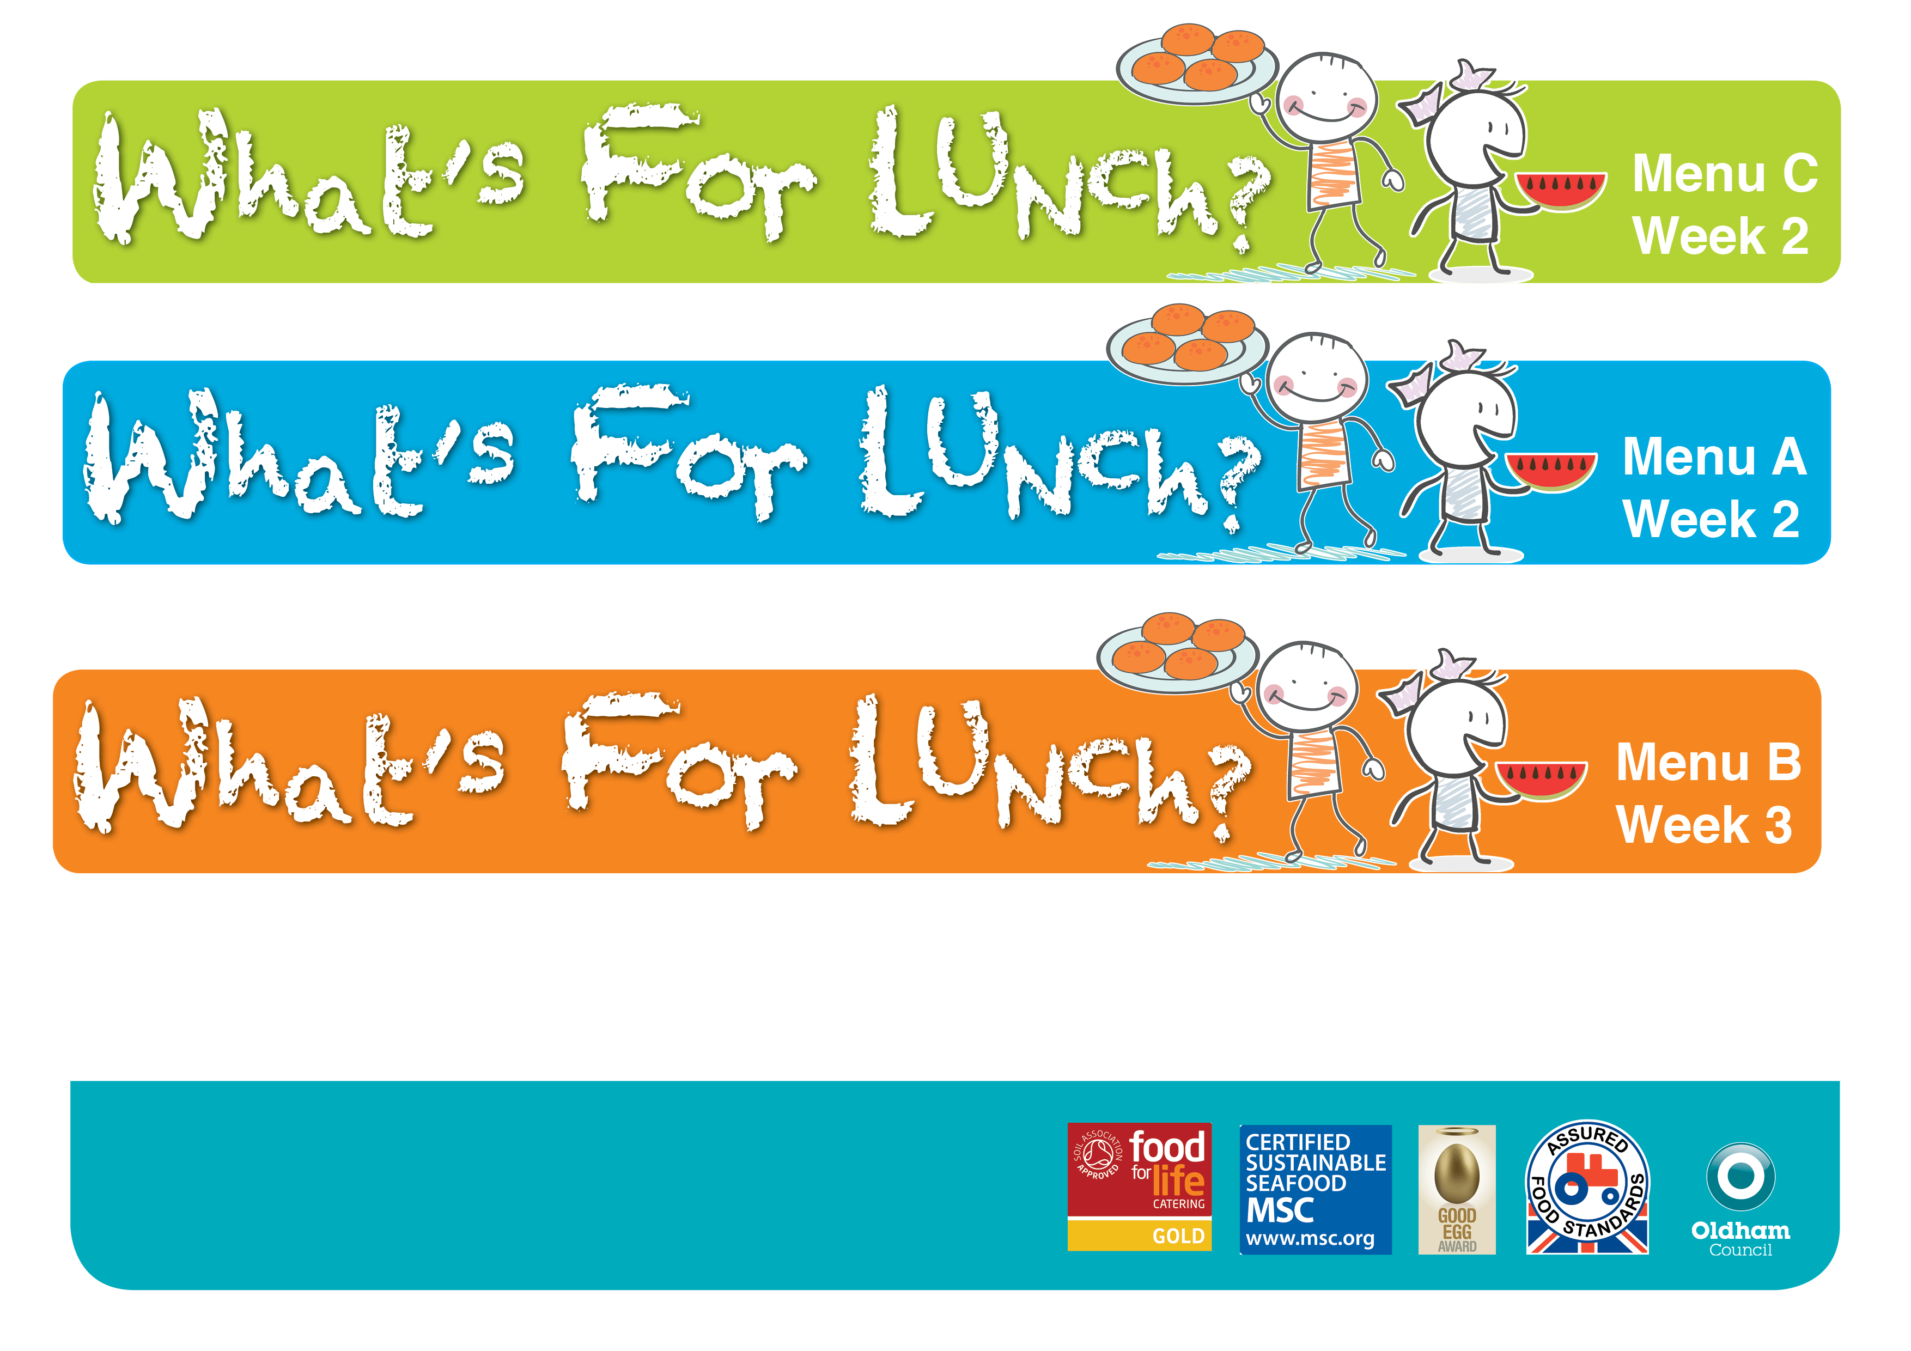 **Spring Summer 2023**  

Over 75% of the food on this menu is homemade by our dedicated Catering Teams and cooked on site. We use high quality regionally sourced products, including some of which are organic. We use higher animal welfare meat and MSC fish. A fresh salad bowl with wholemeal bread and fresh drinking water is served daily.

A fresh salad bar, wholemeal bread and drinking water are available daily.

**H**

