**Choice A**

Homemade Cheese & Tomato Pizza

**Choice B**

Wholemeal Vegetarian Quorn Pasta Bake

**Choice C**

Jacket Potato with Baked Beans Filling

**Vegetable selection**

Oven Baked Chunky Chips

Baked Beans

Salad Pots

**Dessert**

Homemade Banana Muffin served with a glass of milk Organic Yeo Valley Yoghurt Basket of Fresh Seasonal Fruit

Wednesday

Friday Meat Free

Thursday

**Choice A**

Homemade Chicken Fajitas

**Choice B**

Homemade Cheese & Bean Pie

**Choice C**

Wholemeal Tuna & Salad Sandwich

**Vegetable selection**

Oven Baked Herby Diced Potatoes

Medley of Vegetables.

**Dessert**

Ice Cream and Wafer drizzled with Fruit coulis

Basket of Fresh Seasonal Fruit

Organic Yeo Valley Yoghurt

Tuesday Meat free

Wednesday

**Choice A**

Oven Baked Roast Gammon

**Choice B**

Tuna & Sweetcorn Pasta Bake

**Choice C**

Jacket Potato with Cheesy Coleslaw Filling

**Vegetable selection**

Creamed and Roast Potatoes  
Seasonal Vegetables

**Dessert**

Fresh Sliced Melon

Cheese and Biscuits

Basket of Fresh Seasonal Fruit

Organic Yeo Valley Yoghurt

**Choice A**

MSC Fish Fingers

**Choice B**

Homemade Tomato & Cheese Pizza Style Panini

**Choice C**

Jacket Potato with Baked Beans Filling

**Vegetable selection**

Homemade Jacket Wedges

Peas & Sweetcorn

**Dessert**

Homemade Jam Sponge served Creamy Custard.

Basket of Fresh Seasonal Fruit or Fresh Fruit Platter

Organic Yeo Valley Yoghurt

Monday

**Choice A**

Homemade Chilli Con Carne served with 50/50 Rice

**Choice B**

Oven Baked Vegetable Roll

**Choice C**

Pitta filled with Cheese & Salad

**Vegetable selection**

Creamed Potatoes

Baked Beans

**Dessert**

Homemade Shortbread Finger

Basket of Fresh Seasonal Fruit

Organic Yeo Valley Yoghurt

Our award-winning Oldham Education Catering Service guarantees that children are getting a healthy balanced meal 5 days a week using fresh products cooked onsite each day.

**www.oldham.gov.uk/school meals Allergen information available on request**

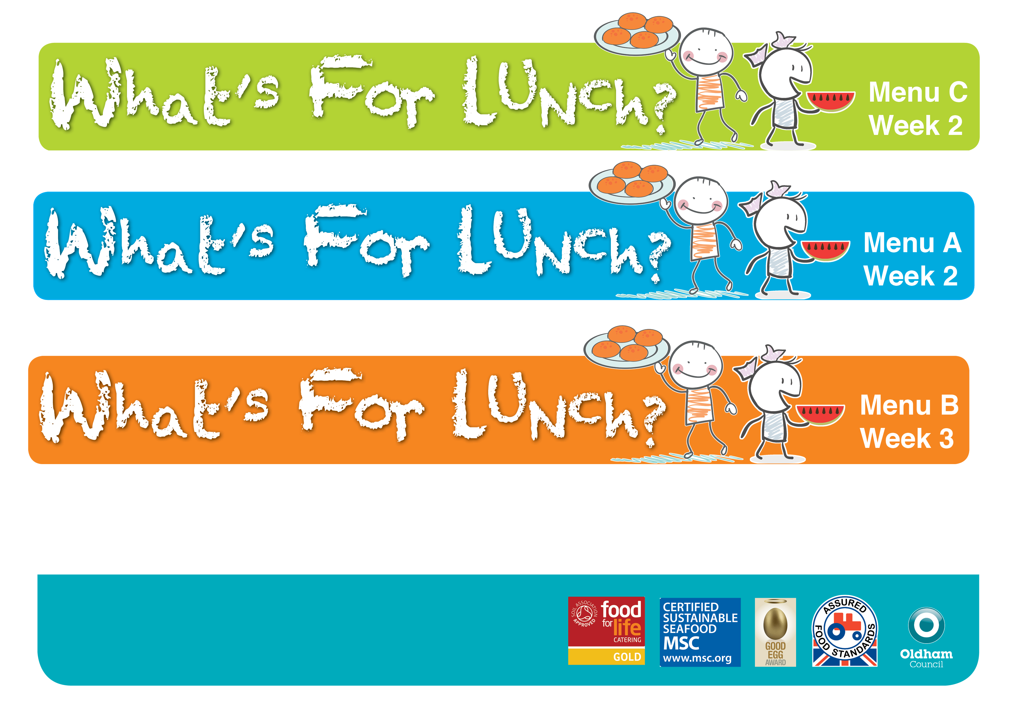 **Spring Summer 2023**  

Over 75% of the food on this menu is homemade by our dedicated Catering Teams and cooked on site. We use high quality regionally sourced products, including some of which are organic. We use higher animal welfare meat and MSC fish. A fresh salad bowl with wholemeal bread and fresh drinking water is served daily.

A fresh salad bar, wholemeal bread and drinking water are available daily.

**h**

